  - ENEMLOS NEWSLETTER Issue 3/2022
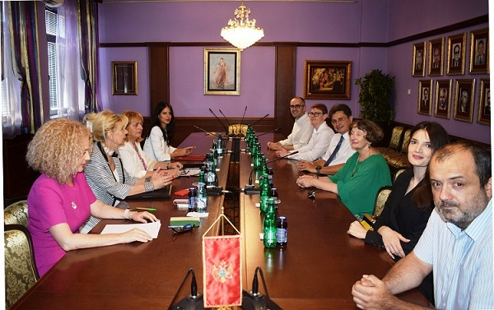 | - July, August, September 2022
Enemlos delagation viseted Supreme Court of Montenegro
In this issue:
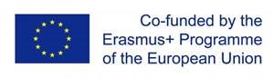 | Zagreb Law Faculty Delegation visited Podgorica Law Faculty Clinics

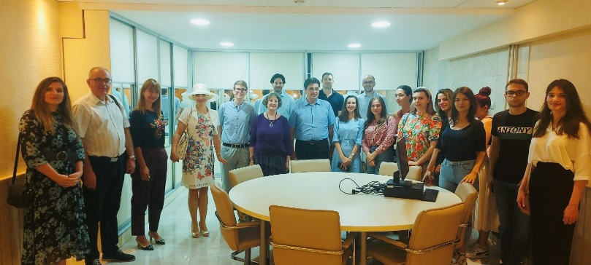
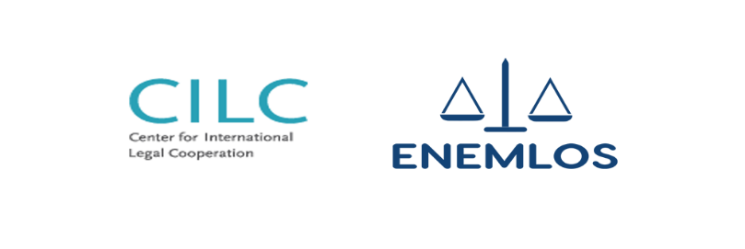
The delegation of the Faculty of Law from Zagreb consisted of: prof. Dr. Alan Uzelac, head of the Legal Clinic in Zagreb, as well as academic mentors Assoc. Dr. Marko Bratković and Dr. Juraj Brozović visited legal clinics at Faculty of Law Podgorica University of Montenegro.
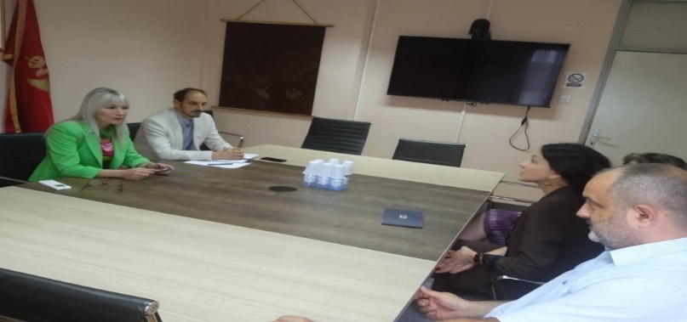

Enemlos project delegation visited Supreme State Prosecutors Office of Montenegro
ERASMUS OFFICE REPRESENTATIVES VISITED CLINICS
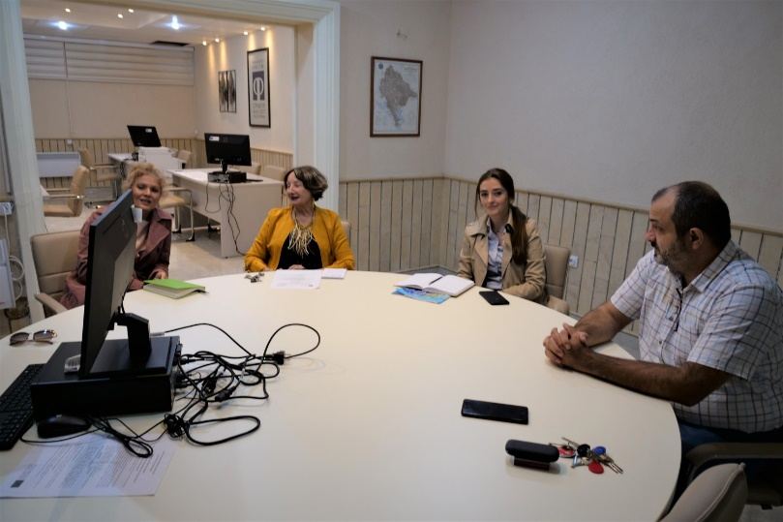
on July, 2022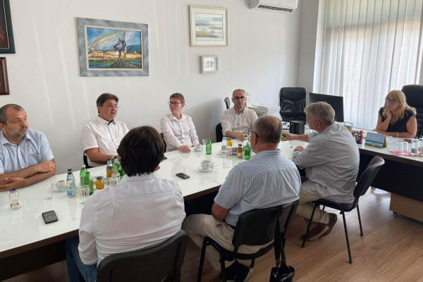

PROJECT ENEMLOS DELEGATION VISIT NOTARY CHAMBER of MONTENEGRO

Poland delegation visited legal clinics
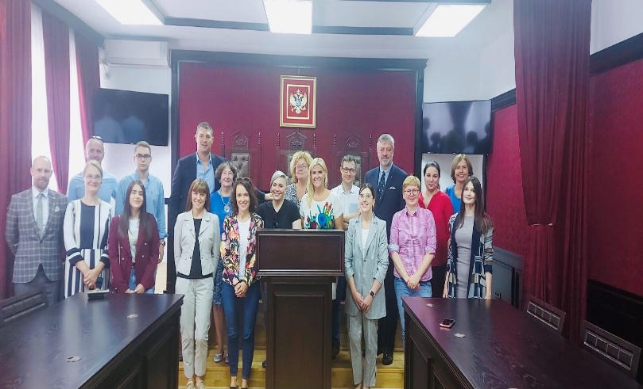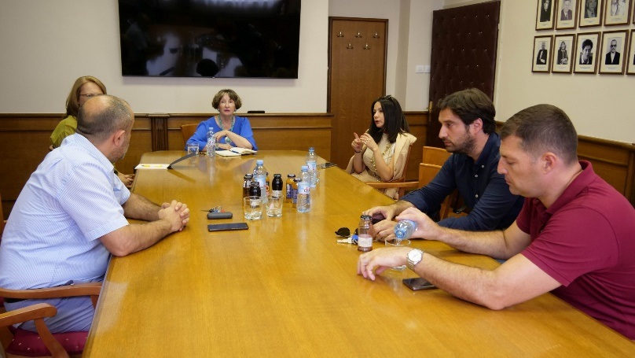
PROJECT MANAGEMENT TEAM MEETING

